Mogu System Operation Introduction

**Step1: Login our site** （<http://54.223.61.98:1080/index>）

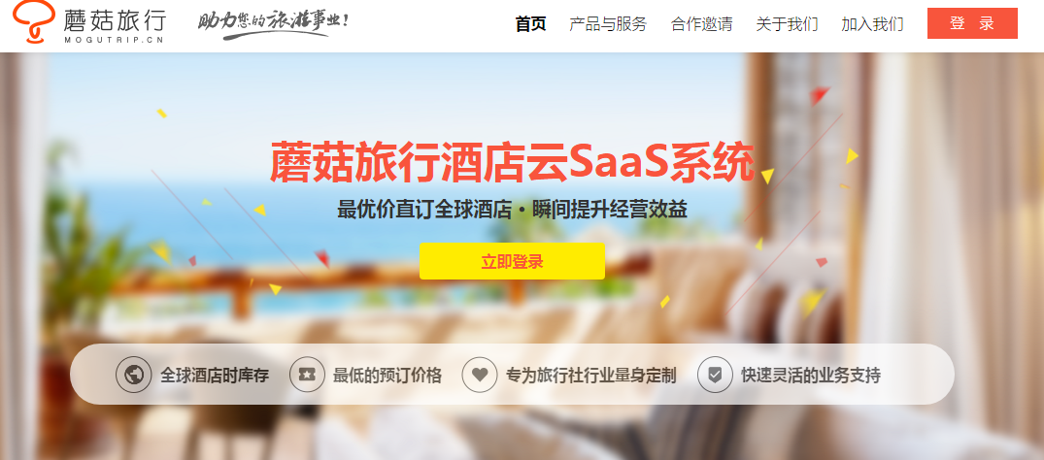

Input AgentCode

Login

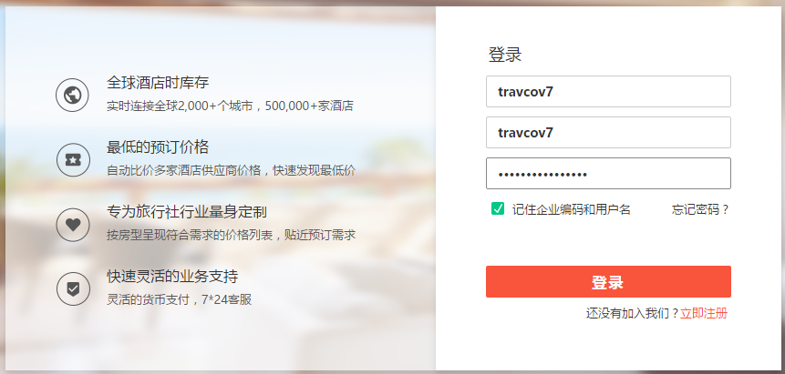

Click to login

Input Password

Input UserCode

Guest nationality, Default is China

**Step 2: Search**

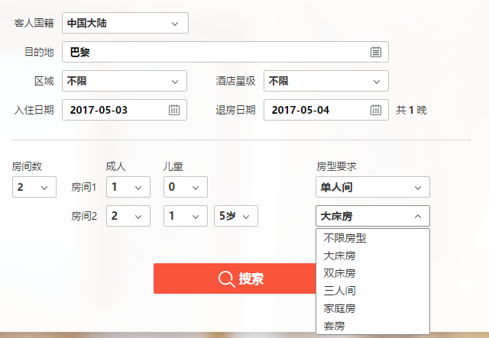

Child number

Adult number

Room type of every room

In order is:

Any

Single

Double

Twin

Triple

Family

Suit

Click to search

Room Numbers

CheckIn & CheckOut

Destination input

Example：London

Child age

**Step 3: select a hotel**

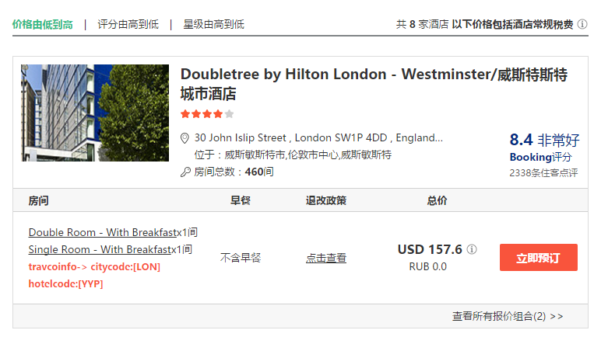

Because we map travco test hotel to mogu hotel arbitrary, So red text refer to travco test hotel code

Click to detail page

**Step 4: detail hotel page**

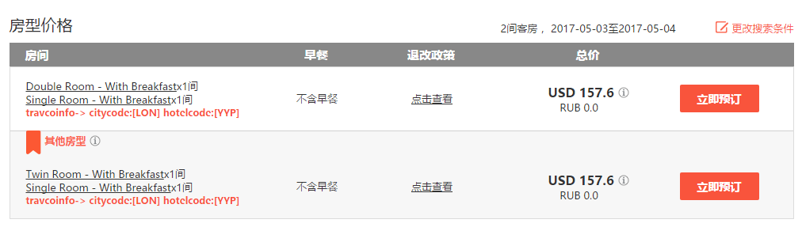

Click to book

**Step 5: fill booking information**

At first, you will see below information, click red button to ignore.

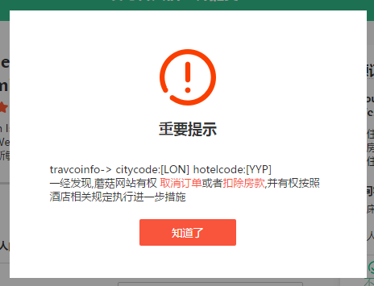

Input guest name

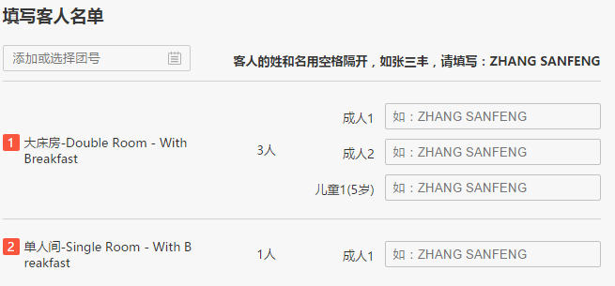

Input guest name

Must input all name

Input contact information

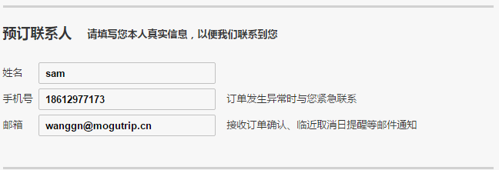

Input contact name, mobile, email

It’s mandatory.

Submit book

Click to submit

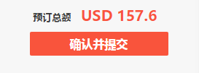

**Step 6: Cancel reservation**

Go to reservation management page from header.



Click here, go to reservation management

Click this link, go to reservation detail page

Select a reservation

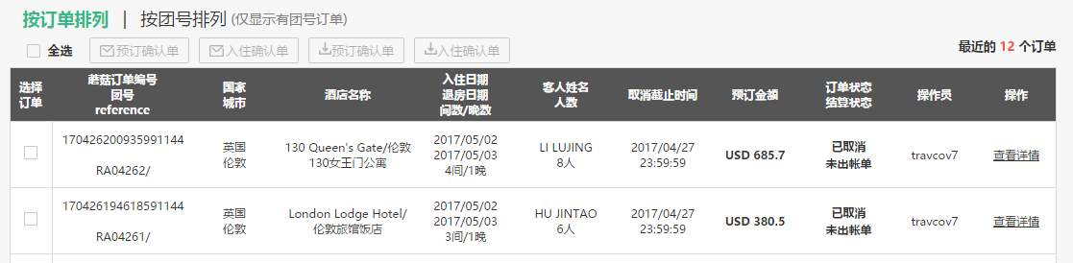

Click gray button to cancel

Cancel a reservation

